Day 23 Emp_ID 112916146

Task 1.

a.

import org.junit.Test;
import static org.junit.Assert.assertEquals;

public class TestJunit {
@Test
public void testSubtract() {
int num1 = 10;
int num2 = 5;
int res = num1 - num2;
assertEquals(5 , res); // Expected 5, check karega
}
}

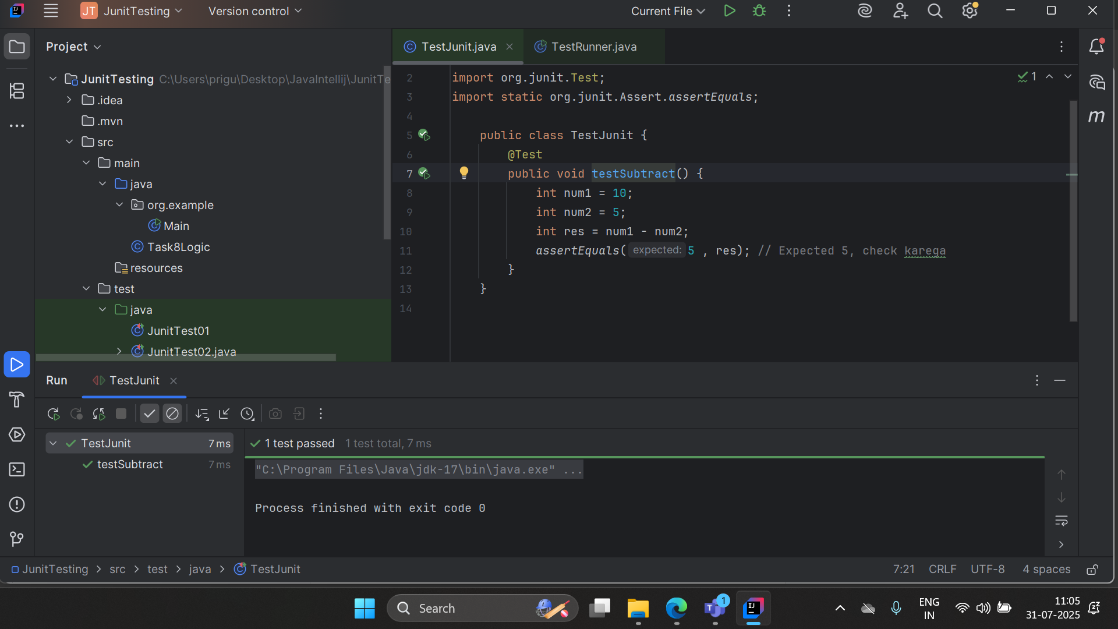

B.

import org.junit.runner.JUnitCore;
import org.junit.runner.Result;
import org.junit.runner.notification.Failure;

public class TestRunner {
public static void main(String[] args) {
// TestJunit class ko run karega
Result resobj = JUnitCore.runClasses(TestJunit.class);

// Agar failures honge to print karega
for (Failure fobj : resobj.getFailures()) {
System.out.println(fobj.toString());
}

// Overall test result
System.out.println("All tests successful? " + resobj.wasSuccessful());
}
}

Result
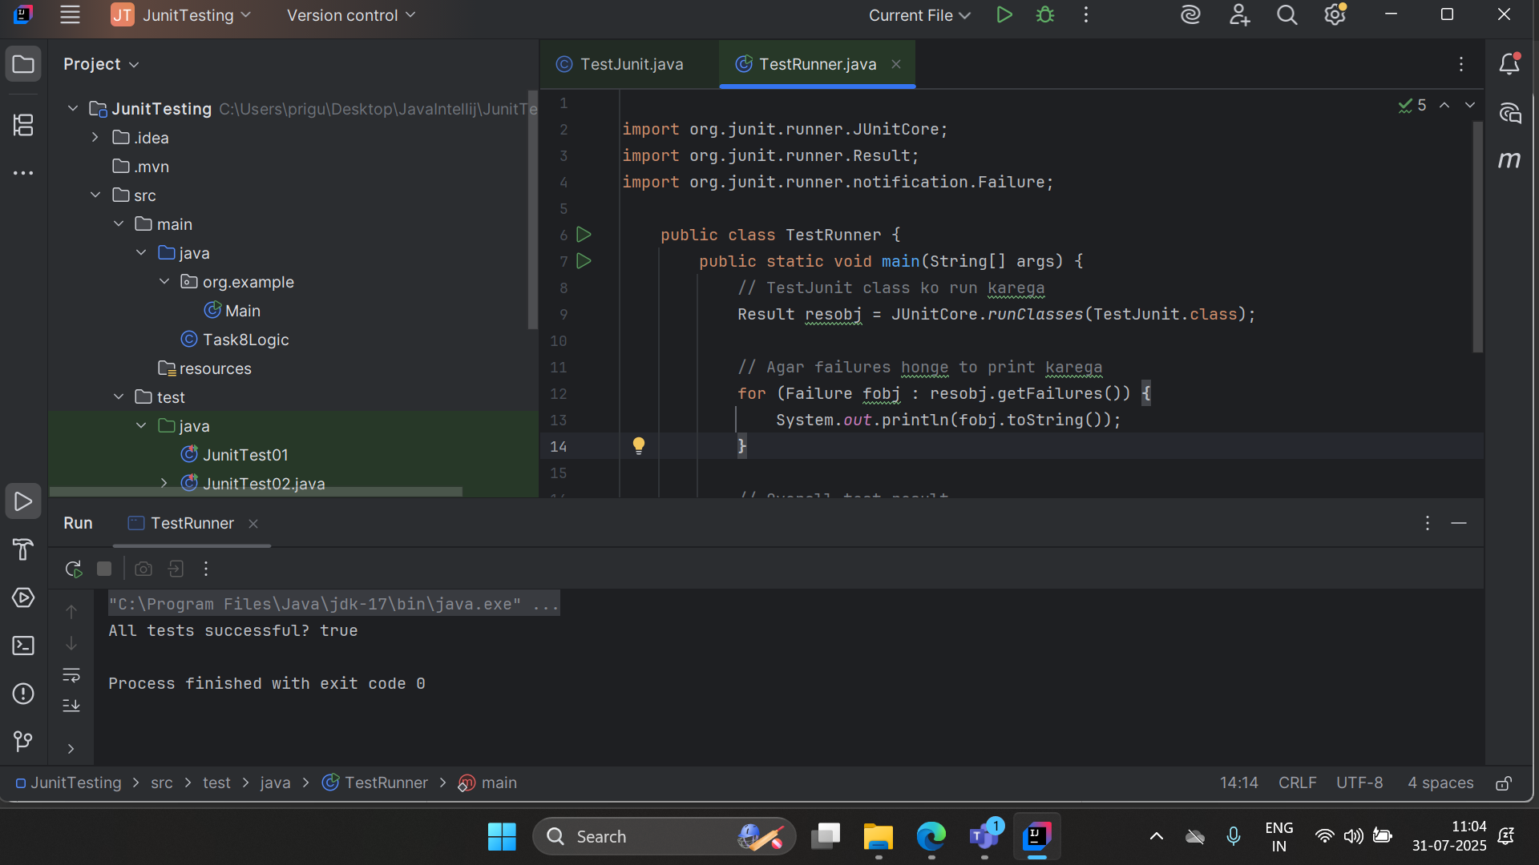

Task2

TestCase

import org.junit.Test;
import static org.junit.Assert.assertEquals;

public class Task2_JunitTest01 {
@Test
public void msgTest() {
System.out.println("We are inside JunitTest01 msgTest()");
String msg = "running test01";
assertEquals("running test01", msg);
}
}

Testcase B.
import org.junit.Test;
import static org.junit.Assert.assertEquals;

public class Task2_JunitTest03 {
@Test
public void msgTest() {
System.out.println("We are inside JunitTest01 msgTest()");
String msg = "running test01";
assertEquals("running test01", msg);
}
}

TestSuite

import org.junit.runner.RunWith;
import org.junit.runners.Suite;

@RunWith(Suite.class)
@Suite.SuiteClasses({
Task2_JunitTest01.class,
Task2_JunitTest03.class
})
class Task2_TestSuiteDemo {
// Empty: Ye bas classes ko group karta hai
}

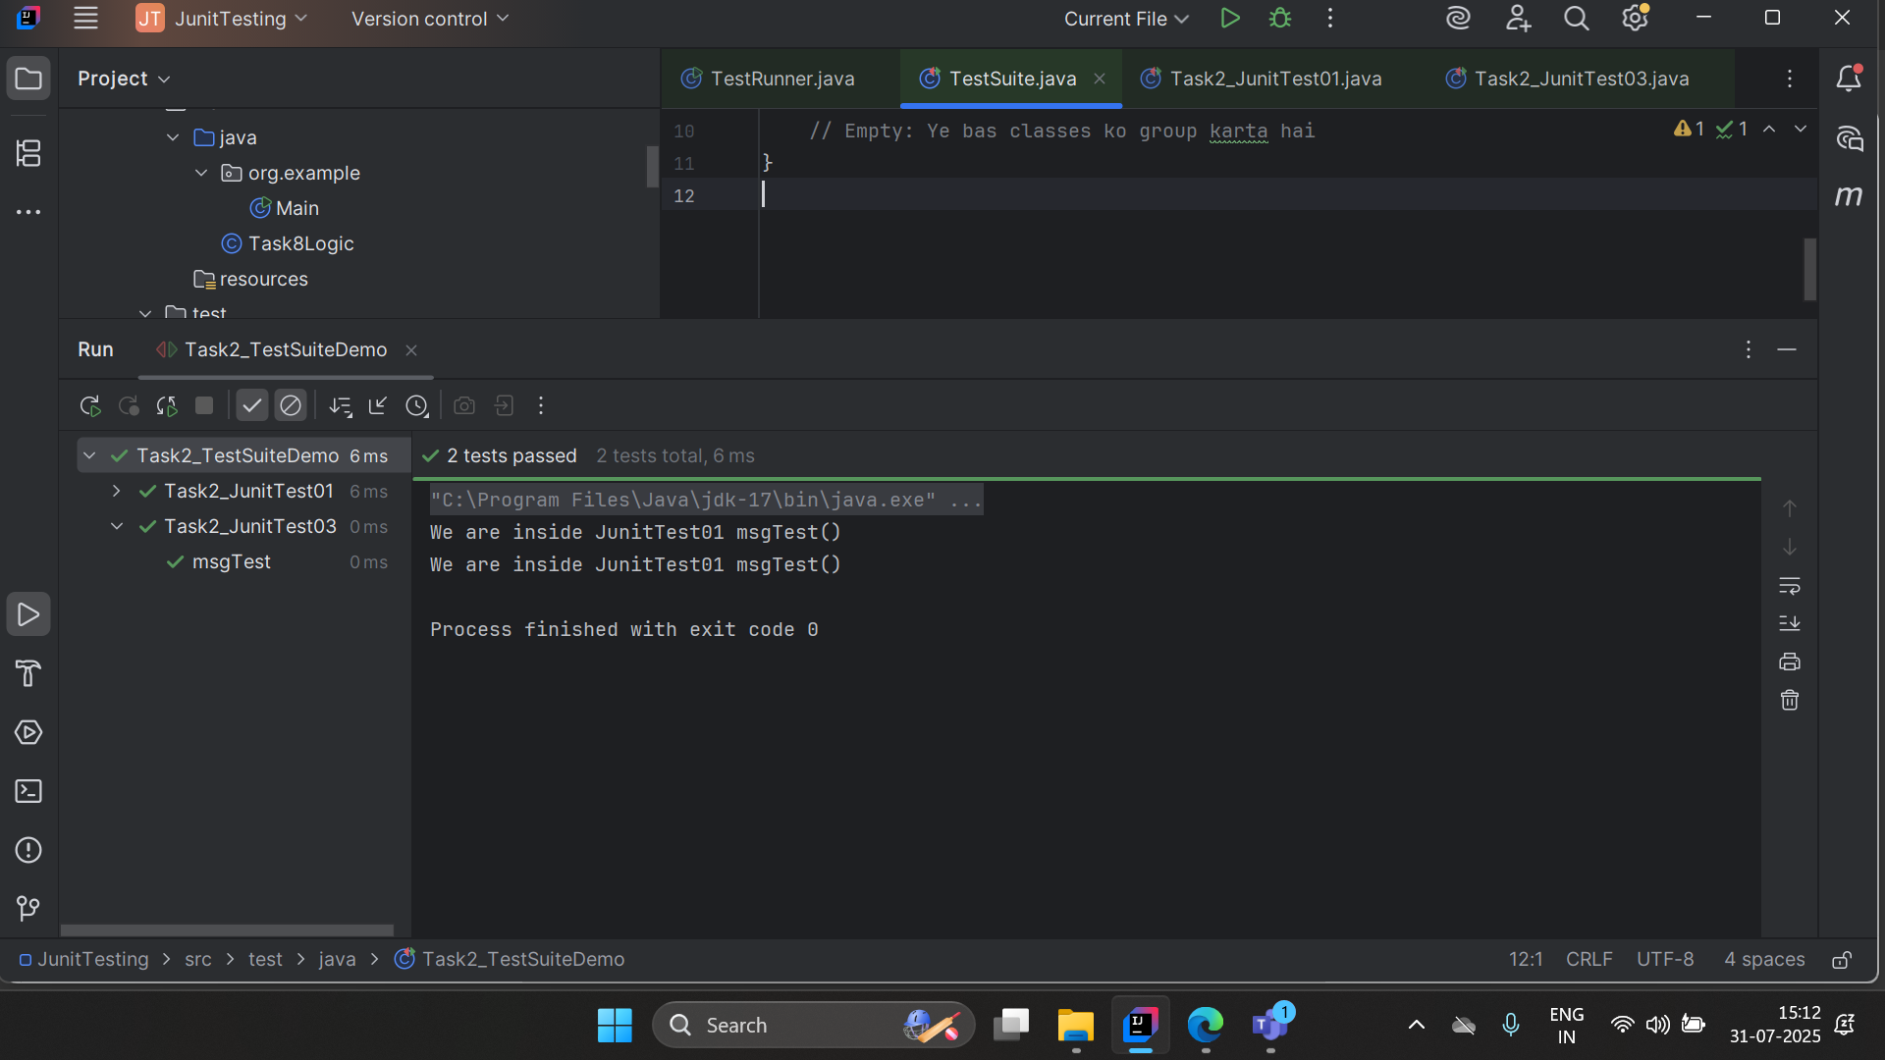

Task 3

import org.junit.Test;
import org.junit.Ignore;
import static org.junit.Assert.*;

public class Assertions {

@Test
public void testSameAndNotSame() {
String str1 = "Hello";
String str2 = "Hello";
String str3 = new String("Hello");

// assertSame - checks if both references point to the same object
assertSame("str1 and str2 should point to same object", str1, str2);

// assertNotSame - checks if both references point to different objects
assertNotSame("str1 and str3 should be different objects", str1, str3);
}

@Ignore("This test is ignored for demo")
@Test
public void testArrayEquals() {
int[] expected = {1, 2, 3};
int[] actual = {1, 2, 3};

// assertArrayEquals - checks if arrays are equal in length & content
assertArrayEquals("Arrays should be equal", expected, actual);
}
}

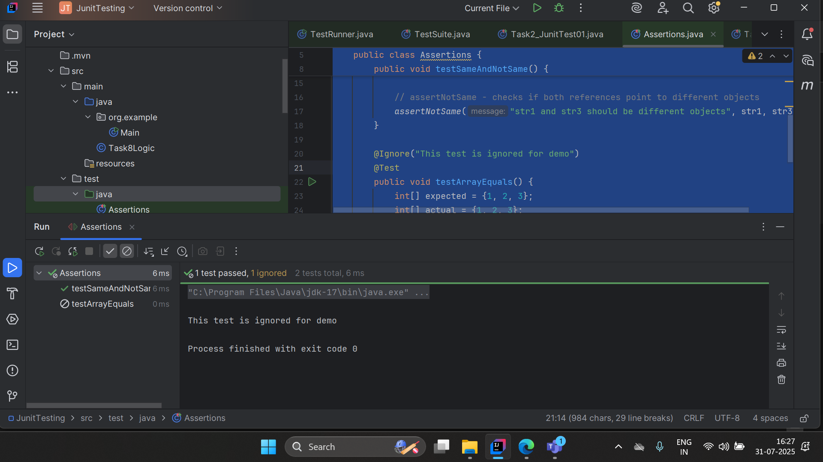

Task 4

import org.junit.Test;
import static org.junit.Assert.*;

public class Task04_timeOut {

@Test(timeout = 1000) // 1000ms = 1 second
public void testWithTimeoutPass() throws InterruptedException {
// This will pass because it finishes before 1 second
Thread.sleep(500); // sleep for 0.5 sec
assertTrue(true);
}

@Test(timeout = 1000) // 1000ms = 1 second
public void testWithTimeoutFail() throws InterruptedException {
// This will fail because it takes more than 1 second
Thread.sleep(2000); // sleep for 2 sec
assertTrue(true);
}
}

Task 5

import org.junit.Test;
import static org.junit.Assert.*;

public class Exception_test {
@Test(expected = ArithmeticException.class)
public void testDivideByZero() {
// This will throw ArithmeticException
int result = 10 / 0;

// The test will fail if exception is NOT thrown
System.out.println("This line will not execute");
}

@Test
public void testNormalDivision() {
// This will pass because no exception
int result = 10 / 2;
assertEquals(5, result);
}
}

Home task

assertEquals(expected, actual)
✔️ Verifies that the expected and actual values are the same.
assertEquals(5, sum);

assertNotEquals(unexpected, actual)
✔️ Verifies that the actual value is not equal to the unexpected value.
assertNotEquals(10, value);

assertTrue(condition)
✔️ Verifies that the condition is true.
assertTrue(a > b);

assertFalse(condition)
✔️ Verifies that the condition is false.
assertFalse(a < b);

assertNull(object)
✔️ Verifies that the object is null.
assertNull(user);

assertNotNull(object)
✔️ Verifies that the object is not null.
assertNotNull(user);

assertSame(expected, actual)
✔️ Verifies that both references point to the same object.
assertSame(obj1, obj2);

assertNotSame(unexpected, actual)
✔️ Verifies that both references point to different objects.
assertNotSame(obj1, obj2);

fail()
✔️ Fails the test intentionally (used to mark failure in certain conditions).
fail("This test is forced to fail!");

